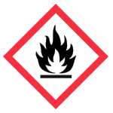 | Flammable Hazard | 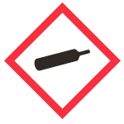 | Gases Under Pressure | 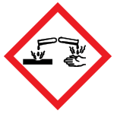 | Corrosion Hazard
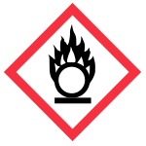 | Oxidizing Hazard | 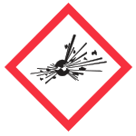 | Exploding Bomb  (for explosion or reactivity hazards) | 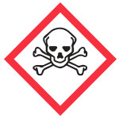 | Can Cause Death or Toxicity with Short Exposure to Small Amounts
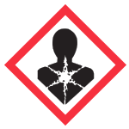 | Health Hazard  (May cause or suspected to cause serious health effects) | 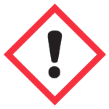 | May cause less serious health effects or damage the ozone layer | 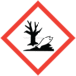 | Environmental Hazard
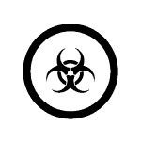 | Biohazardous Infectious Materials  (for organisms or toxins that can cause diseases in people or animals)

