Modifying Electrochemical Cells /20

Name: _________________________
Each question is worth 5 marks. 2 marks for your chart, 1 for your conclusion, and 2 for your graph.
http://www.learnalberta.ca/content/secsu/html/electrical_principles_and_technologies/ModifyingElectrochemicalCells/index.html
- Type of Electrode:
Combination of Electrodes | Voltage (V)

Which combination gave the greatest voltage?

Graph:
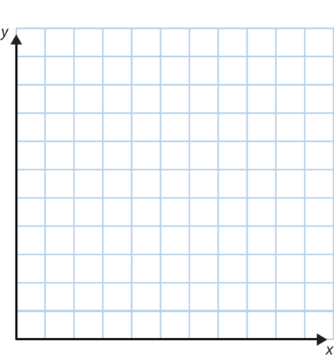

- Type of Electrolyte:
Type of Solution | Voltage (V)

Which Solution was the best electrolyte?

Graph:

- Concentration of Solution:
% Concentration of Solution | Voltage (V)

As you increased the % concentration of the solution, what happened to the voltage?

Graph:
- Temperature of Solution:
Temperature (°C) of Solution | Voltage (V)

How did the temperature affect the voltage?

Graph:

