Distance and Displacement

Distance and Displacement: What’s the Difference?!

Name: ______________________________

**A** 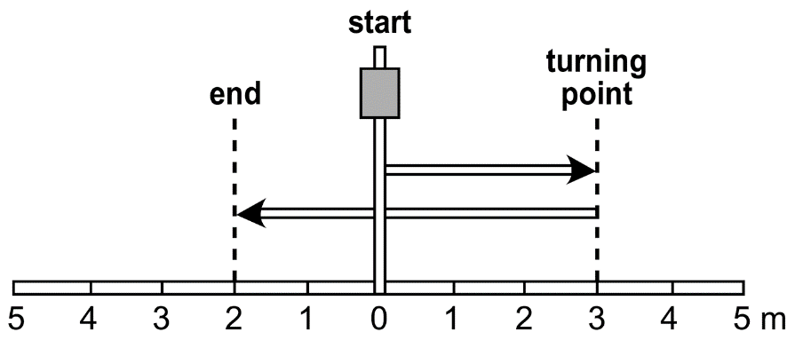

**Distance travelled** is a scalar quantity. It is a measurement of the change in distance of an object moving from a starting reference point.

In diagram A above, the person first moves 3 m to the right of the bus stop. Then he turns and moves 5 m back past the bus stop. The total distance travelled from the bus stop is:

Δ*d* = 3 m + 5 m = 8 m

**B** 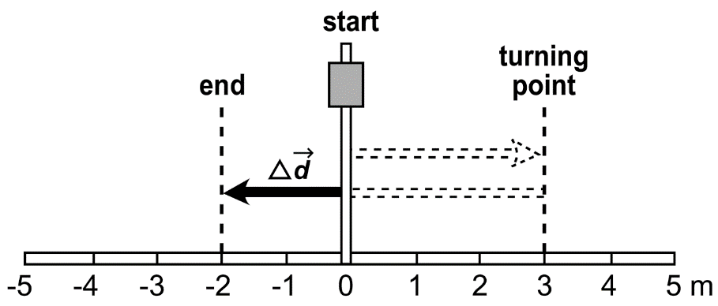

**Displacement** is a vector quantity. It is a measurement of the change in distance *and* the direction or the change in position of an object from a reference point.

Diagram B shows the displacement of the person from his original starting point at the stop sign. The displacement from the starting point at the bus stop is:

Δ = 3 m [right] + −5 m [left] = −2 m [left]