Chemistry 30 Course Outline

Block 2. Ms. Redding, Room 213
Website: www.msrredding.weebly.com
Email: rebecca.pullishy@sturgeon.ab.ca OR rebecca.redding@sturgeon.ab.ca

My goal is to create a safe, engaging environment where students can take risks, grow and develop the necessary confidence to overcome obstacles and challenges. These expectations and routines are in place in order to help every student in the classroom succeed in this course. If I am concerned about your success in any way, I may contact your parents/guardians and/or the administration for further support.

Classroom Expectations and Routines
Absences: You are expected to take an active part in your schooling. For this reason, you are responsible for finding out about missed assignments as well as what went on in class while you were absent. You will absolutely not be hunted down over missed work! This includes information about exams and quizzes. The excuse “I wasn’t here so I didn’t know”, has no validity in this classroom. Finally, class time will not be used to catch you up in any way.
Eating/drinking: Any food or drink brought to class must not be disruptive and must be cleaned up after. Abuse of this guideline will result in the privilege being taken away. No food or drink is allowed during labs.
Late for class: Please be on time as it is disruptive for the class if you are late. If you are late please enter the classroom quietly.
Leaving class: Please ask me for permission should you need to leave class. To further avoid disruption, I ask that only one student be out at a time, so please be considerate of others and keep your breaks short. Abusing a break (ex. wandering the halls/hanging out) will result in the loss of this privilege. If you need to leave class early for other commitments please let me know ahead of time.
Cell phones: Please no cell phone use during class. Phones should be turned off and kept out of sight at all times.
Laptops/iPods/MP3 players: These devices are permitted only during seat work (not during lesson time). Electronic devices of any type are prohibited in any examination (including quizzes).
Be respectful to everyone in the classroom: That includes listening while others are speaking, respecting other’s property and use of appropriate language (ex. no swearing).

Chemistry 30 consists of four core units. The core is designed as a continuation of chemistry 20 and a good background in chemistry 20 will be an asset in this course.
Text: Nelson Chemistry
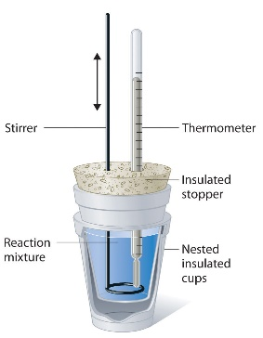
1. Review of Chemistry 20. This will include nomenclature, balancing equations, stoichiometry, gas laws, bonding and organic chemistry.
(3 days)

2. Thermochemical Changes (20%): This unit concentrates on the energy transfer that accompanies chemical processes. You will learn how to predict the energy changes in chemical reactions as well as measure these changes in the lab. The energy involved in phase changes, chemical changes and nuclear changes will be discussed. (15 days)

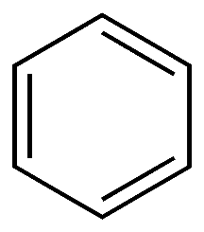
3. Electrochemical Change (30%): This unit focuses on two primary processes -the generation of an electrical current from a chemical reaction and the use of a current to produce a chemical change. Learn the shocking truth. (25 days)

4. Organic Chemistry (20%): This unit focuses on the shape of molecules as well as the structure of acids, esters, alcohols and other compounds. Students will work on nomenclature and drawing these structures. (14 days)

5. Acids and Bases (30%): This unit will involve a study of the properties of acids and bases and the special reactions that occur between them. It will also include rates of reactions and equilibrium reactions. (25 days)

Evaluation/Assessment:
The course is composed of 4 units. There will be daily formative course work and it is essential that this work is completed to ensure success on summative work.
Students will be evaluated on their summative course work – tests, quizzes, lab reports and Unit Exams.
Chemistry 30 consists of four units of study:
- Thermochemistry – 20% of course work
- Electrochemical Change – 30% of course work
- Organic Chemistry – 20% of course work
- Equilibrium, Acids and Bases – 30% of course work

Within each unit, 60% of the student’s grade comes from quizzes and assignments; the remaining 40% will come from Unit exams and tests.

