Chemistry 30
Ms. Rebecca Redding (Pullishy): rebecca.redding@sturgeon.ab.ca
Visit: msrredding.weebly.com for notes and videos.
Chemistry 30 consists of four core units. The core is designed as a continuation of chemistry 20 and a good background in chemistry 20 will be an asset in this course.
Text: Nelson Chemistry
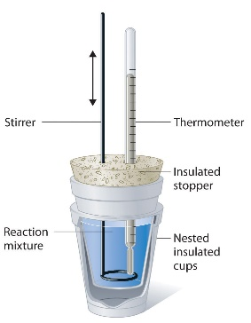
1. Review of Chemistry 20. This will include nomenclature, balancing equations, stoichiometry, gas laws, bonding and organic chemistry. (3 days)

2. Thermochemical Changes (20%): This unit concentrates on the energy transfer that accompanies chemical processes. You will learn how to predict the energy changes in chemical reactions as well as measure these changes in the lab. The energy involved in phase changes, chemical changes and nuclear changes will be discussed. (15 days)

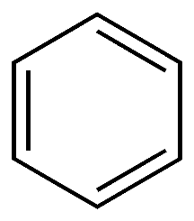
3. Electrochemical Change (30%): This unit focuses on two primary processes -the generation of an electrical current from a chemical reaction and the use of a current to produce a chemical change. Learn the shocking truth. (25 days)

4. Organic Chemistry (20%): This unit focuses on the shape of molecules as well as the structure of acids, esters, alcohols and other compounds. Students will work on nomenclature and drawing these structures. (14 days)

5. Acids and Bases (30%): This unit will involve a study of the properties of acids and bases and the special reactions that occur between them. It will also include rates of reactions and equilibrium reactions. (25 days)

Evaluation: Your Final Grade is comprised of your course work and diploma results; 70% for your school based work and 30% for your diploma. Your school awarded mark is based on the following:
Tests/Quizzes/Assignments/Labs 60%
Unit Exams 40%

Lates: It is expected that you will be in your desk and ready to work by the second bell. If you should come late to class, you will often find the door closed and locked. Please do not bang on the door, just knock politely and I will let you in as soon as it is convenient to do so.

Absences: You are expected to take an active part in your schooling. For this reason, you are responsible for finding out about missed assignments. I will not hunt you down over missed work. Arrangements should be made immediately upon your return to school to get missed work in. Some assignments and labs may be impossible to repeat and for these assignments you may have to accept an alternative assignment. If you have to miss a test or a quiz for any reason, phone the school office BEFORE the scheduled exam or quiz and have the secretary's report this to me.

