Chemistry 20 Course Outline

Block 2. Ms. Redding, Room 213
Website: www.msrredding.weebly.com
Email: rebecca.pullishy@sturgeon.ab.ca OR rebecca.redding@sturgeon.ab.ca

My goal is to create a safe, engaging environment where students can take risks, grow and develop the necessary confidence to overcome obstacles and challenges. These expectations and routines are in place in order to help every student in the classroom succeed in this course. If I am concerned about your success in any way, I may contact your parents/guardians and/or the administration for further support.

Classroom Expectations and Routines
Absences: You are expected to take an active part in your schooling. For this reason, you are responsible for finding out about missed assignments as well as what went on in class while you were absent. You will absolutely not be hunted down over missed work! This includes information about exams and quizzes. The excuse “I wasn’t here so I didn’t know”, has no validity in this classroom. Finally, class time will not be used to catch you up in any way.
Eating/drinking: Any food or drink brought to class must not be disruptive and must be cleaned up after. Abuse of this guideline will result in the privilege being taken away. No food or drink is allowed during labs.
Late for class: Please be on time as it is disruptive for the class if you are late. If you are late please enter the classroom quietly.
Leaving class: Please ask me for permission should you need to leave class. To further avoid disruption, I ask that only one student be out at a time, so please be considerate of others and keep your breaks short. Abusing a break (ex. wandering the halls/hanging out) will result in the loss of this privilege. If you need to leave class early for other commitments please let me know ahead of time.
Cell phones: Please no cell phone use during class. Phones should be turned off and kept out of sight at all times.
Laptops/iPods/MP3 players: These devices are permitted only during seat work (not during lesson time). Electronic devices of any type are prohibited in any examination (including quizzes).
Be respectful to everyone in the classroom: That includes listening while others are speaking, respecting other’s property and use of appropriate language (ex. no swearing).

The recommended prerequisite for Chemistry 20 is 65% or more in Science 10. Students with below a 65% will be put on probation and a letter will be sent home for parents to sign.
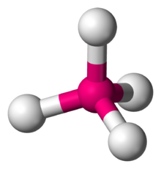
Text: Nelson Chemistry
Unit A: The Diversity of Matter and Chemical Bonding
Themes: Diversity and Matter
Overview: Concepts, models and theories are often used in interpreting and explaining observations and in predicting future observations. The major focus of this unit is to relate theories about bonding to the properties of matter and to develop explanations and descriptions of structure and bonding through scientific models. Students learn about the diversity of matter through the investigation of ionic compounds and molecular substances.
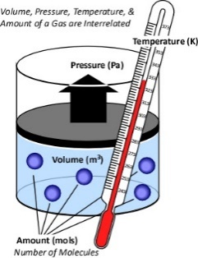
Unit B: Forms of Matter: Gases
Themes: Matter, Change and Energy
Overview: Students expand their knowledge of the nature of matter through the investigation of the properties and behaviour of gases.

Unit C: Matter as Solutions, Acids and Bases
Themes: Matter, Diversity, Systems and Change
Overview: Students gain insight into the nature of matter through an investigation of change in the context of solutions, acids and bases.

Unit D: Quantitative Relationships in Chemical Changes
Themes: Matter and Change
Overview: Students focus on chemical change and the quantitative relationships contained in balanced chemical equations. They are required to use stoichiometric principles and mathematical manipulation to predict quantities of substances consumed or produced in chemical reaction systems.

Evaluation/Assessment:
The course is composed of 4 units. There will be daily formative course work and it is essential that this work is completed to ensure success on summative work.
Students will be evaluated on their summative course work – tests, quizzes, lab reports and Unit Exams.
Chemistry 20 consists of four units of study:
- Diversity of Matter and Chemical Bonding – comprises 20% of the course work
- Gases as a form of Matter – comprises 16% of the course work
- Solutions, Acids and Bases – comprises 32% of the course work
- Quantitative Relationships in Chemical Change – comprises 32% of the course work

Within each unit, 60% of the student’s grade comes from quizzes and assignments; the remaining 40% will come from Unit exams and tests.

