Chemistry 20
Ms. Rebecca Redding (Pullishy): rebecca.redding@sturgeon.ab.ca
Visit: msrredding.weebly.com for notes and videos.
The recommended prerequisite for Chemistry 20 is 65% or more in Science 10. Students with below a 65% will be put on probation and a letter will be sent home for parents to sign.
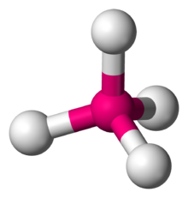
Text: Nelson Chemistry
Unit A: The Diversity of Matter and Chemical Bonding
Themes: Diversity and Matter
Overview: Concepts, models and theories are often used in interpreting and explaining observations and in predicting future observations. The major focus of this unit is to relate theories about bonding to the properties of matter and to develop explanations and descriptions of structure and bonding through scientific models. Students learn about the diversity of matter through the investigation of ionic compounds and molecular substances.
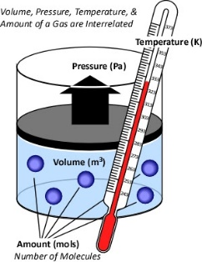
Unit B: Forms of Matter: Gases
Themes: Matter, Change and Energy
Overview: Students expand their knowledge of the nature of matter through the investigation of the properties and behaviour of gases.

Unit C: Matter as Solutions, Acids and Bases
Themes: Matter, Diversity, Systems and Change
Overview: Students gain insight into the nature of matter through an investigation of change in the context of solutions, acids and bases.

Unit D: Quantitative Relationships in Chemical Changes
Themes: Matter and Change
Overview: Students focus on chemical change and the quantitative relationships contained in balanced chemical equations. They are required to use stoichiometric principles and mathematical manipulation to predict quantities of substances consumed or produced in chemical reaction systems.

Diversity of Matter and Chemical Bonding – comprises 20% of the course work
Gases as a form of Matter – comprises 16% of the course work
Solutions, Acids and Bases – comprises 32% of the course work
Quantitative Relationships in Chemical Change – comprises 32% of the course work

Evaluation: Student grades will be determined by a culmination of summative assignments/labs/projects/labs as well as Unit exams. No formative work will affect your overall grade. Unit exams count for 40% of each Units overall mark and all summative work will comprise the remaining 60%. Course work is worth 70% of the final grade, with the Final Exam worth the remaining 30%.

Lates: It is expected that you will be in your desk and ready to work by the second bell. If you should come late to class, you will often find the door closed and locked. Please do not bang on the door, just knock politely and I will let you in as soon as it is convenient to do so.

Absences: You are expected to take an active part in your schooling. For this reason, you are responsible for finding out about missed assignments. I will not hunt you down over missed work. Arrangements should be made immediately upon your return to school to get missed work in. Some assignments and labs may be impossible to repeat and for these assignments you may have to accept an alternative assignment. If you have to miss a test or a quiz for any reason, phone the school office BEFORE the scheduled exam or quiz and have the secretary's report this to me.

