Chemistry 20: Titration Stoichiometry Worksheet
When reading a burette you must read the position of the meniscus at eye level as shown.
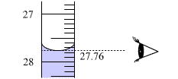  With your eyes level with the titrant surface read the value, from the bottom of the meniscus, to within1/10th of the smallest division on the scale. | The difference between any two consecutive readings from a burette, the Initial and Final burette volumes respectively, is called a titre. This is the volume of titrant, in the burette, added to the sample. The scale runs, and is read, down the way.

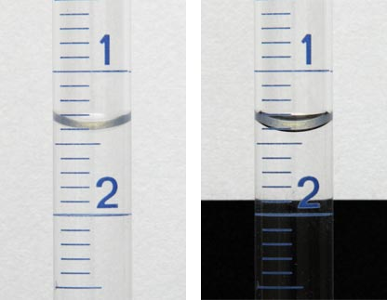 | A white reader card cuts out background glare and makes it easier to read the volume of titrant in a burette. Note that the scale runs down the way. Here the volume is ca 1.42 mL. (Probably an initial burette volume.)

Read the volumes from the following pictured burettes

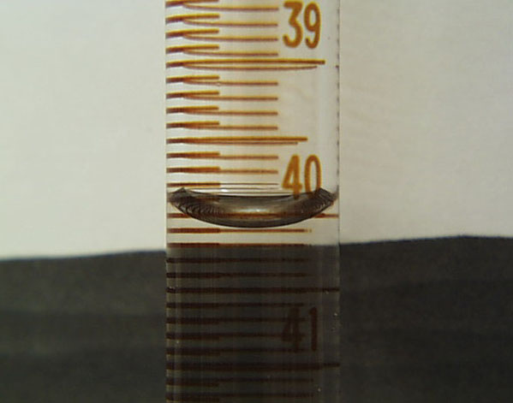
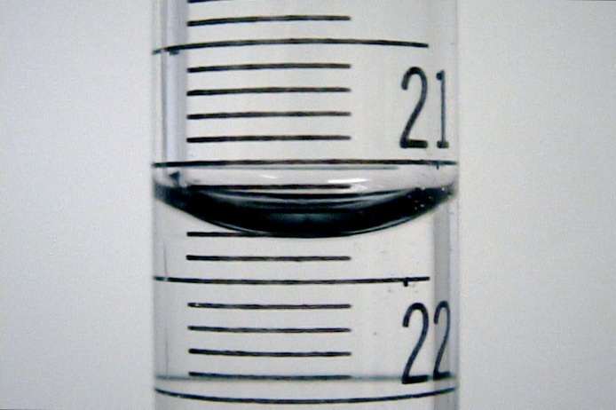
Volume is ______mL Volume is ______mL
- The following data was collected during the standardization of hydrochloric acid with sodium carbonate :

Volumes of HCl(aq) added to 10.0 mL samples of 0.100 mol/L Na₂CO₃(aq)

Trial # | 1 | 2 | 3 | 4
Final Burette Volume (mL) | 13.00 | 24.50 | 36.10 | 47.65
Initial Burette Volume (mL) | 0.00 | 13.00 | 24.50 | 36.10
Endpoint colour (Phenolphthalein) | Deep pink | Light pink | Light pink | Light pink

Calculate the concentration of the acid solution.

- The following data was collected during the titration analysis of NaOH(aq) samples with 0.173 mol/L HCl(aq):

Volumes of 0.173 mol/L HCl(aq) added to 10.0 mL samples of NaOH(aq)

Trial # | 1 | 2 | 3 | 4
Final Burette Volume (mL) | 14.00 | 24.20 | 34.40 | 44.55
Initial Burette Volume (mL) | 1.00 | 14.00 | 24.20 | 34.40
Endpoint colour (Methyl orange) | Deep red | Light red | Light red | Light red

Calculate the concentration of the sodium hydroxide solution.

- The data below records the volumes of 0.176 mol/L NaOH(aq) added to 10.0 mL samples of sulfuric acid:

Volumes of 0.176 mol/L NaOH(aq) added to 10.0 mL samples of H₂SO₄(aq)

Trial # | 1 | 2 | 3 | 4
Final Burette Volume (mL) | 14.40 | 26.40 | 38.45 | 12.95
Initial Burette Volume (mL) | 0.00 | 14.40 | 26.40 | 1.00
Endpoint colour (Phenolphthalein) | Deep pink | Light pink | Light pink | Light pink

Calculate the concentration of the acid.

- The following data was collected during the titration of 25.0 mL samples of diluted household vinegar (acetic acid) with 0.176 mol/L aqueous sodium hydroxide:

Volumes of 0.176 mol/L NaOH(aq) added to 25.0 mL samples of CH₃COOH(aq)

Trial # | 1 | 2 | 3 | 4
Final Burette Volume (mL) | 12.50 | 24.33 | 36.22 | 48.08
Initial Burette Volume (mL) | 0.00 | 12.50 | 24.33 | 36.22
Endpoint colour (Phenolphthalein) | Deep pink | Light pink | Light pink | Light pink

Calculate the concentration of the diluted vinegar solution.

If the vinegar solution was diluted by a factor of 10 what is the concentration of vinegar in the undiluted, store bought, sample?

- The following data was collected during the titration of 10.0 mL samples of 0.200 mol/L nitric acid with aqueous barium hydroxide solution:

Volumes of Ba(OH)₂(aq) added to 10.0 mL samples of 0.200 mol/L HNO₃(aq)

Trial # | 1 | 2 | 3 | 4
Final Burette Volume (mL) | 16.5 | 27.9 | 39.5 | 32.4
Initial Burette Volume (mL) | 4.6 | 16.5 | 27.9 | 20.9
Endpoint colour (Phenolphthalein) | Deep pink | Light pink | Light pink | Light pink

Calculate the concentration of the barium hydroxide solution.

- The following data was collected during the titration of 10.0 mL samples of citric acid, C₃H₅O(COOH)₃(aq), with a 0.100 mol/L sodium hydroxide solution:

Volumes of 0.100 mol/L NaOH(aq) added to 10.0 mL samples of C₃H₅O(COOH)₃(aq)

Trial # | 1 | 2 | 3 | 4
Final Burette Volume (mL) | 16.4 | 28.9 | 41.5 | 12.7
Initial Burette Volume (mL) | 0.0 | 16.4 | 28.9 | 0.0
Endpoint colour (Phenolphthalein) | Deep pink | Light pink | Light pink | Light pink

The citric acid reacts as follows

3 NaOH(aq) + C₃H₅O(COOH)₃(aq) Na₃C₃H₅O(COO)₃(aq) + 3 H₂O(l)

Calculate the concentration of the citric acid solution.

