Travel Brochure Rubric

 | Possible  Points | Earned  Points
5 Accurate Facts Presented in an Interesting Way | 5
Description of Surface: Temperature, Atmospheric Gases, Gravity, Energy Sources, Rotation, and Revolution. | 10
Minimum 2 Pictures | 5
2 credible sources of information are used and cited | 4
Presentation: Brochure is Exciting, Colorful, Neat, Interesting, & Factual | 10
Name on back cover | 1
Teacher Comments:
Total Score | 35

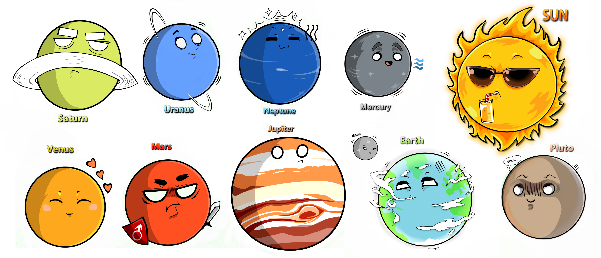

Name: _________________________________________________ Date: __________________________________ Period: _____________

Planet Research Guide
Take notes on your planet to help develop your presentation!

Name the planet you are researching: _________________________________________________________

Revolution : _______________ Earth days

Rotation : _______________ Earth days

Location

☐ Inner Planet
☐ Outer Planet

_________ Planet from the sun

Size

☐ Bigger than Earth
☐ Smaller than Earth

What is the planet made of?

☐ Terrestrial (made of rock)
☐ Jovian (made of gas)

Accessories
**include how many if known**
☐ Moons _______________
☐ Rings _________________

Describe the planet’s surface features
*Terrain, craters, volcanoes, etc.*

Appearance

Color: _______________________________

Interesting facts about the way it looks?

What is the planet’s atmosphere like?
*Main gases* *thick/thin*

What is the planet’s weather like?
*Be sure to include temperatures* *storms* *clouds*

What are some things that make your planet unique or special?
Include things you want people to know! **Fun Facts**

Surface Gravity:

____________________________________________________

____________________________________________________

☐ Greater than Earth
☐ Less than Earth

Have humans ever explored this planet?
Probes, robots, etc.

