**Intel HD:Users:teacher:Library:Application Support:Microsoft:Office:Clipart:Personal:an02121_.wmfIntel HD:Users:teacher:Library:Application Support:Microsoft:Office:Clipart:Personal:j0091113.wmfMonohybrid Mice!**

***Directions:*** Solve each problem showing your work. For each cross, give the genotypes and phenotypes of the offspring and the probability of getting each. Answer the questions that accompany each problem.

***What you need to know about the mice:*** In laboratory mice, gray coat color (G) is dominant over albino coat color (g).

**I. Cross a female Gg with a male gg.**

1. What is the probability of getting gray offspring?

2. What is the probability of getting albino offspring?

3. How many possible genotypes are there among the offspring?

4. How many possible phenotypes are there among the offspring?

5. What is the probability of getting heterozygous offspring?

6. What is the probability of getting homozygous offspring?

7. What color is the female?

8. What color is the male?

**II. Cross a homozygous gray female with a heterozygous male.**

1. What is the probability of getting gray offspring?

Intel HD:Users:teacher:Library:Application Support:Microsoft:Office:Clipart:Personal:an00597_.wmf2. What is the probability of getting albino offspring?

3. How many possible genotypes are there among the offspring?

4. How many possible phenotypes are there among the offspring?

5. What is the probability of getting heterozygous offspring?

6. What is the probability of getting homozygous offspring?

7. What is the genotype of the female?

8. What color is the male?

**III. Cross a gray female, whose father was albino, with a heterozygous male.**

1. What is the probability of getting gray offspring?

Intel HD:Users:teacher:Library:Application Support:Microsoft:Office:Clipart:Personal:j0091111.wmf2. What is the probability of getting albino offspring?

3. How many possible genotypes are there among the offspring?

4. How many possible phenotypes are there among the offspring?

5. What is the probability of getting heterozygous offspring?

6. What is the probability of getting homozygous offspring?

7. What is the genotype of the female? How do you know?

8. What is the genotype of the male? How do you know?

Intel HD:Users:teacher:Library:Application Support:Microsoft:Office:Clipart:Personal:an04011_.wmf**IV. Cross an albino female, whose father was gray, with a gray male, whose mother was albino.**

1. What is the probability of getting gray offspring?

2. What is the probability of getting albino offspring?

3. How many possible genotypes are there among the offspring?

4. How many possible phenotypes are there among the offspring?

5. What is the probability of getting heterozygous offspring?

6. What is the probability of getting homozygous offspring?

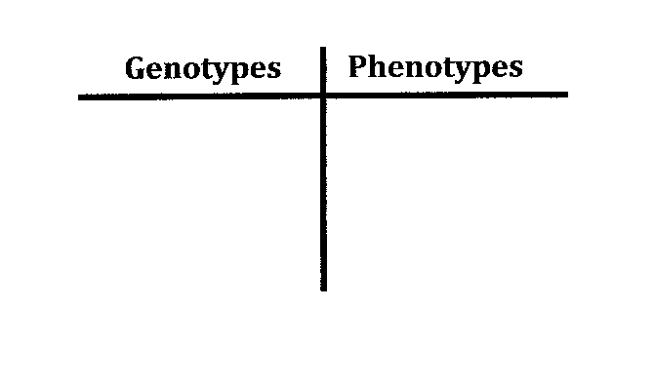7. What was the genotype of the father of the albino female?

**Intel HD:Users:teacher:Library:Application Support:Microsoft:Office:Clipart:Personal:j0091113.wmf**Name \_\_\_\_\_\_\_\_\_\_\_\_\_\_\_\_\_\_\_\_\_\_\_\_\_

**Intel HD:Users:teacher:Library:Application Support:Microsoft:Office:Clipart:Personal:an02121_.wmf**

Date \_\_\_\_\_\_\_\_\_\_\_

**Monohybrid Mice!**

***Directions:*** Solve each problem showing your work in the Punnett square. For each cross, give the genotypes and phenotypes of the offspring and the probability of getting each. List these in the table seen by each problem. Answer the questions that accompany each problem.

::Library:Application Support:Microsoft:Office:Clipart:Personal:j0329658.wmf***What you need to know about the mice:*** In laboratory mice, gray coat color (G) is dominant over albino coat color. (g).



**I. Cross a female Gg with a male gg.**

\_\_\_\_\_\_\_\_\_\_\_1. What is the probability of getting gray offspring?

\_\_\_\_\_\_\_\_\_\_\_2. What is the probability of getting albino offspring?

::Library:Application Support:Microsoft:Office:Clipart:Personal:j0139545.wmf\_\_\_\_\_\_\_\_\_\_\_3. How many possible genotypes are there among the offspring?

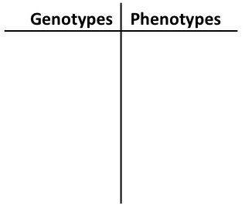\_\_\_\_\_\_\_\_\_\_\_4. How many possible phenotypes are there among the offspring?

\_\_\_\_\_\_\_\_\_\_\_5. What is the probability of getting heterozygous offspring?

\_\_\_\_\_\_\_\_\_\_\_6. What is the probability of getting homozygous offspring?

\_\_\_\_\_\_\_\_\_\_\_7. What color is the female?

\_\_\_\_\_\_\_\_\_\_\_8. What color is the male?

**II. Cross a homozygous gray female with a heterozygous male.**



\_\_\_\_\_\_\_\_\_\_\_1. What is the probability of getting gray offspring?

\_\_\_\_\_\_\_\_\_\_\_2. What is the probability of getting albino offspring?

\_\_\_\_\_\_\_\_\_\_\_3. How many possible genotypes are there among the offspring?

\_\_\_\_\_\_\_\_\_\_\_4. How many possible phenotypes are there among the offspring?

\_\_\_\_\_\_\_\_\_\_\_5. What is the probability of getting heterozygous offspring?

\_\_\_\_\_\_\_\_\_\_\_6. What is the probability of getting homozygous offspring?

\_\_\_\_\_\_\_\_\_\_\_7. What is the genotype of the female?

\_\_\_\_\_\_\_\_\_\_\_8. What color is the male?

::Library:Application Support:Microsoft:Office:Clipart:Personal:bd07336_.wmf

::Library:Application Support:Microsoft:Office:Clipart:Personal:bd07336_.wmf

**III. Cross a gray female, whose father was albino, with a heterozygous male.**





Intel HD:Users:teacher:Library:Application Support:Microsoft:Office:Clipart:Personal:j0091111.wmf

\_\_\_\_\_\_\_\_\_\_1. What is the probability of getting gray offspring?

\_\_\_\_\_\_\_\_\_\_2. What is the probability of getting albino offspring?

\_\_\_\_\_\_\_\_\_\_3. How many possible genotypes are there among the offspring?

\_\_\_\_\_\_\_\_\_\_4. How many possible phenotypes are there among the offspring?

\_\_\_\_\_\_\_\_\_\_5. What is the probability of getting heterozygous offspring?

\_\_\_\_\_\_\_\_\_\_6. What is the probability of getting homozygous offspring?

\_\_\_\_\_\_\_\_\_\_7. What is the genotype of the female? How do you know?

\_\_\_\_\_\_\_\_\_\_8. What is the genotype of the male? How do you know?

**IV. Cross an albino female, whose father was gray, with a gray male, whose mother was albino.**



::Library:Application Support:Microsoft:Office:Clipart:Personal:an04029_.wmf

\_\_\_\_\_\_\_\_\_\_1. What is the probability of getting gray offspring?

\_\_\_\_\_\_\_\_\_\_2. What is the probability of getting albino offspring?

Intel HD:Users:teacher:Library:Application Support:Microsoft:Office:Clipart:Personal:an04011_.wmf\_\_\_\_\_\_\_\_\_\_3. How many possible genotypes are there among the offspring?

\_\_\_\_\_\_\_\_\_\_4. How many possible phenotypes are there among the offspring?

\_\_\_\_\_\_\_\_\_\_5. What is the probability of getting heterozygous offspring?

\_\_\_\_\_\_\_\_\_\_6. What is the probability of getting homozygous offspring?

\_\_\_\_\_\_\_\_\_\_7. What was the genotype of the father of the albino female?

**© Amy Brown Science**

**\*\*\*Answer Key\*\*\***

I. Genotypes: ½ Gg and ½ gg

Phenotypes: ½ Gray and ½ albino

1) ½

2) ½

3) 2

4) 2

5) ½

6) ½

7) Gray

8) Albino

II. Genotypes: ½ Gg and ½ GG

Phenotypes: 2/2 Gray

1) 1

2) 0

3) 2

4) 1

5) ½

6) ½

7) GG

8) Gray

III. Genotypes: ¼ GG, 2/4 Gg

and ¼ gg

Phenotypes: ¾ Gray and ¼ albino

1) ¾

2) ¼

3) 3

4) 2

5) ½

6) ½

7) Gg. She is gray and must have at least one “G”. Since her father was albino, she had to receive a “g” from him.

8) Gg. The term heterozygous means that the two alleles are different.

IV. Genotypes: ½ Gg and ½ gg

Phenotypes: ½ Gray and ½ albino

1) ½

2) ½

3) 2

4) 2

5) ½

6) ½

7) Gg. If he is gray, he must have a “G”. To have an albino daughter, he must also have a “g”.

**Created by Amy Brown Science**

**Copyright © Amy Brown Science**

**All rights reserved by author.**

**This document is for your classroom use only.**

**This document may not be electronically distributed or posted to a web site.**

**http://www.teacherspayteachers.com/Store/Amy-Brown-Science**