Energy & Matter in Chemical Change
Section 1.0 Handouts

Recall: Lab Safety Rules
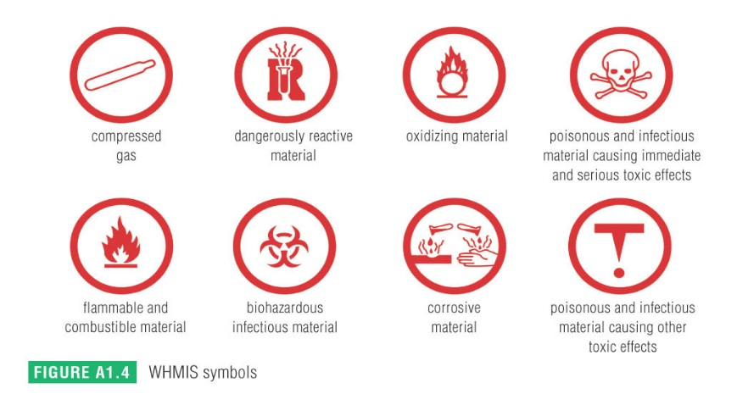
1. Read all written instructions carefully before doing an activity.
2. Listen to all instructions and follow them carefully.
3. Wash your hands thoroughly after each activity and after handling chemicals.
4. Wear safety goggles, gloves, or an apron as required.
5. Think before you touch. Equipment may be hot and substances may be dangerous.
6. Smell a substance by fanning the smell toward you with your hand. Do not put your nose close to the substance.
7. Do not taste anything in the lab.
8. Tie back loose hair and roll up loose sleeves.
9. Never pour liquids into containers held in your hand. Place a test tube in a rack before pouring substances into it.
10. Clean up any spilled substances immediately as instructed by your teacher.
11. Never look into test tubes or containers from the top. Always look through the sides.
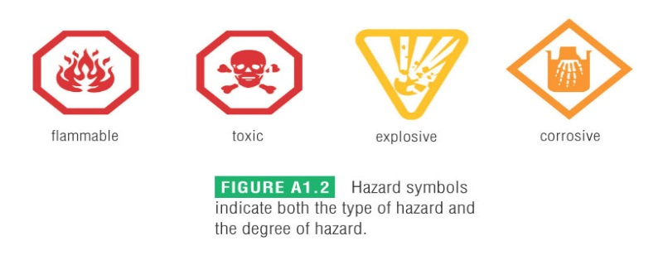
12. Never use cracked or broken glassware. Make sure you follow your teacher’s instructions when getting rid of broken glass.
13. Label any container you put chemicals in.
14. Report all accidents and spills immediately to your teacher.
15. Read the WHMIS (Workplace Hazardous Materials Information System) safety symbols on any chemical you will be using and make sure you understand all of them. See Student Reference 1 at the back of Science 10 for more information.

Lab Write Up Requirements
RW Science Lab Report Rubric Name: ____________________________
Category | 4 | 3 | 2 | 1
Components / Organization / Appearance | All required elements are present. Lab report is very neatly written. Pen was used or lab was typed up.  Headings used to visually organize material. | One required element is missing. Lab report is neatly written but formatting does not visually organize the material. Pencil may have been used | 2-3 required elements are missing. Written work is sloppy and formatting is disorganized. Pencil was used | Several elements are missing. Poorly written. Very sloppy formatting. Lots of cross-outs, erasures, creases, tears, etc.
Variables | 1 Manipulated,  1 Responding, 2-3 Controlled. Variables are clearly and accurately identified. | Missing one variable or one incorrect variable. | 2 incorrect or missing variables. | 3 or more incorrect or missing variables.
Result: Data / Graphs / Diagrams | Professional looking, accurate, detailed results. Rulers are used. Titles/Headings included. | Results are well done, fairly accurate. Ruler used. Titles/Headings included. | Messy, partially accurate. Includes some heading. | Very messy, inaccurate, no headings, no ruler.
Analysis | Answers are extremely clear, use scientific language, evidence from lab used to support answer, answer all the questions | Answers are well written, use some appropriate terms, evidence from lab partially used, answered all the questions | Answers are unclear, terms used are not scientific, rare use of evidence from lab, missed one question | Did not answer majority of questions, poorly written, answers completely wrong
Conclusion | Conclusion includes: answer to question, whether findings supported hypothesis, what was learned from the lab. Organized in a clear, neat and thoughtful fashion. | Included 2 of the required elements. Well organized. | Included 1 of the required elements. Poorly organized. | Completely incorrect information. Did not include a conclusion.
Spelling, Punctuation, Grammar | One or fewer errors in spelling, punctuation and grammar. | Two or three errors. | Four to five errors. | Many errors.

