Muttart Conservatory Biomes Exploration

Biomes are areas around the world that are categorized based on climate (average temperature and precipitation). Plants and animals have specific adaptations that help them to survive and thrive in these locations.

While exploring the Muttart Conservatory, please be respectful of other guests and the staff. DO NOT pick any plants, and do not leave the designated pathways.

You may complete the following sections in any order, but you must complete this entire booklet before your teacher will give you the password for the photo scavenger hunt.

Part A – Biome Location Mapping (suggested time ~15 minutes)

At the entrance to each main pyramid, there is a map that indicates the locations of each biome around the world. Using pencil crayons, complete the map of CANADA attached to the back of this booklet.

Part B – Climatographs (suggested time: ~20 minutes)

- Using the data and the charts attached at the back of this booklet, complete a climatographs for the arid and tropical biomes.
  - Remember, average monthly temperature is a LINE graph, average monthly precipitation is a BAR graph.

- Using a red pen, draw a straight line on the appropriate climatograph of the average temperature as indicated in that biome’s pyramid.

Part C - Plant Adaptations (suggested time ~15 minutes)

Plants found native to each biome have certain adaptations that help them to survive in the conditions present. Complete the following chart (at least three adaptations for each biome) with observations, information provided on signs, pamphlets, staff, books or the internet.

Biome | Plant Adaptation | Explain how this adaptation is beneficial to life in this biome
Tropical
Arid
Temperate

Part D – Plant Sketches (suggested time ~20 minutes)

Choose a plant from each biome (Arid, Temperate, Tropical, Feature Pyramid) and complete a general sketch. Remember to properly label the specimen with it’s common name, taxonomic name, and where in the world it is found.

Part E – Analysis Questions (suggested time ~15 minutes)

- Which biomes tend to border each other?

- Think of a possible animal adaptation for each of the three main biomes visited (arid, temperate, tropical).

- Complete the following chart
Biome | Human Impact | Hypothesize how this biome would be affected
Arid | Ozone depletion (an increase in solar radiation)
Tropical | Climate change (a decrease in average precipitation)
Temperate | Deforestation (the removal of trees by clearcutting)

- Many plants have traditional uses by indigenous cultures found in the same area. Find and describe four examples of plant use from the arid and temperate biomes.

Biome | Plant (common name and taxonomic name) | Use
Arid
Temperate
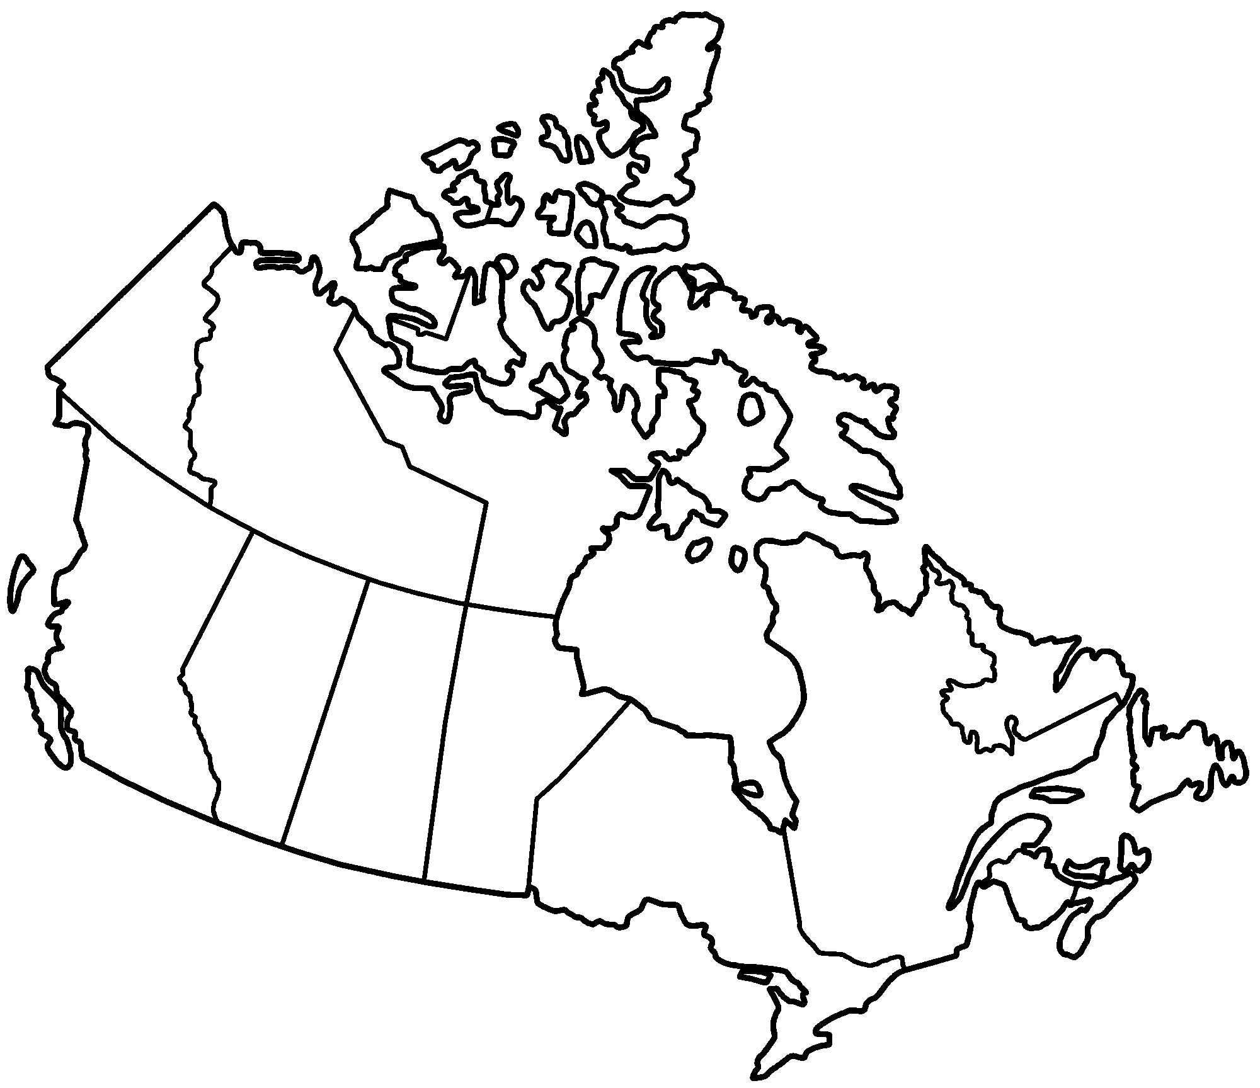
Key

- Dessert and Xeric Shrub
- Broadleaf and Mixed Forests
- Coniferous Forests
- Boreal Forests/Taiga
- Grasslands
- Tundra

Part B – Climatographs

Las Vegas, Nevada (arid)
 | Jan | Feb | Mar | Apr | May | Jun | Jul | Aug | Sep | Oct | Nov | Dec
Ave Temp (ºC) | 8 | 11 | 13 | 18 | 23 | 29 | 34 | 32 | 27 | 20 | 13 | 8
Ave Precip (cm) | 1.5 | 1.5 | 1 | 0.5 | 0.5 | 0.5 | 1 | 1.5 | 1 | 0.5 | 1 | 1

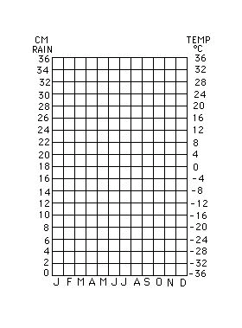

Manaus, Brazil (tropical)
 | Jan | Feb | Mar | Apr | May | Jun | Jul | Aug | Sep | Oct | Nov | Dec
Ave Temp (ºC) | 26 | 26 | 27 | 27 | 28 | 28 | 28 | 28 | 27 | 27 | 26 | 26
Ave Precip (cm) | 25 | 27 | 32.5 | 30 | 27 | 10 | 8 | 5 | 7 | 10 | 15 | 20

