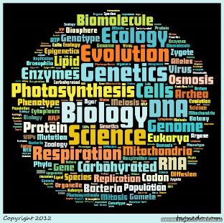Mechanisms of Population

Change

Name: _______________________________

*Use this booklet to help you navigate Chapter 4 along with the aid of your textbook.*

**Section 4.1 – Adaptation, Variation and Natural Selection**

1. Adaptation –
2. Variation –
3. A shark has an excellent sense of smell, is this an adaptation or variation? Why?
4. How does sexual reproduction lead to variation?
5. Mutation –
6. What are three factors that can cause mutations to occur?
7. Are all mutations bad? Give an example to explain.
8. Selective Advantage –
9. Natural Selection
10. Can variation in a species be caused by a mutation? Use pages 119-120 for an example
11. List 5 adaptations that a grizzly bear have that make it well suited for survival in its habitat.
12. What does selection pressure do to a species or a population?
13. Explain what is meant by the expression “populations evolve, not individuals”



**Section 4.2 – Developing a Theory to Explain Change**

1. What is the theory of evolution by natural selection?
2. There were many people who contributed to the theory of evolution by natural selection. What did each of these individuals contribute?
   1. George-Louis Leclerc, Comte de Buffon
   2. Georges Cuvier
   3. Charles Lyell
   4. Jean-Baptiste Lamarck
   5. Charles Darwin
   6. Alfred Russell Wallace
   7. Thomas Mathus
3. Inheritance of Acquired Characteristics –
4. What was Burgess Shale? How was it useful in studying fossils?
5. What were the two main ideas Darwin proposed in his book ‘on the origin of species’?



1. How could competition for resources lead to natural selection?
2. Using the geological time scale on page 128, summarize the 12 main periods.
   1. Precambrian
   2. Cambrian
   3. Ordovician
   4. Silurian
   5. Devonian
   6. Carboniferous
   7. Permian



* 1. Triassic
  2. Jurassic
  3. Cretaceous
  4. Tertiary
  5. Quaternary



1. Transition fossils –
2. Biogeography –
3. Homologous structures –
4. Examples of homologous structures:
5. Analogous structures –
6. Examples of analogous Structures:
7. Are bird and bat wings homologous or analogous? Explain?
8. How have genetics and molecular biology helped scientists contribute and refine the theory of natural selection?

**Section 4.3 – How species form**

1. Species –
2. Speciation –
3. Transformation –
4. Divergence –
5. Geographical Barriers –
6. Examples of geographical barriers:
7. How can geographical isolation lead to speciation?
8. Biological Barriers –
9. Examples of biological barriers:
10. Adaptive Radiation –
11. Gradualism –
12. Punctuated Equilibrium –
13. Explain the difference between habitat isolation and a geographical barrier to reproduction.