Lab: Calculating Velocity

Name: ______________________________

Graphical Analysis of Uniform Motion (Average Velocity)

**Using the stop watches provided, you are going to collect your data. Record your findings in the chart below.**

1. Complete the following table of values and draw a position-time graph of the motion.

|  |  |  |
| --- | --- | --- |
| **Group Member** | **Time**  ***t* (s)** | **Position**  **(m) [direction]** |
|  |  |  |
|  |  |  |
|  |  |  |
|  |  |  |
|  |  |  |
|  |  |  |
|  |  |  |
|  |  |  |
|  |  |  |
|  |  |  |
|  |  |  |
|  |  |  |

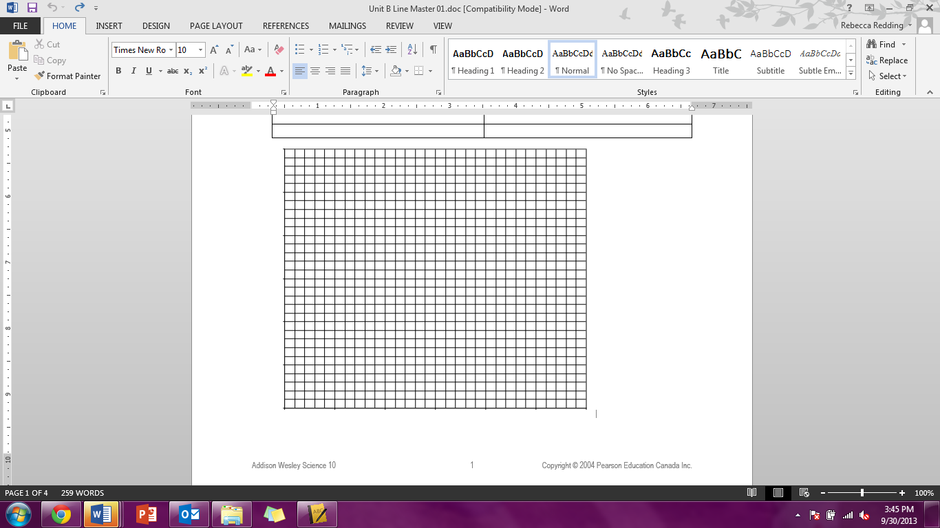Graph the data below:

1. What was each person’s average velocity? Show your work.
2. Calculate the initial velocities of each person (from distance zero to the approx.. mid-point mark) as well as the final velocities. Did they start or end faster. Show all of your work.