MC900389354[1]

October 2017

rebecca.redding@sturgeon.ab.ca

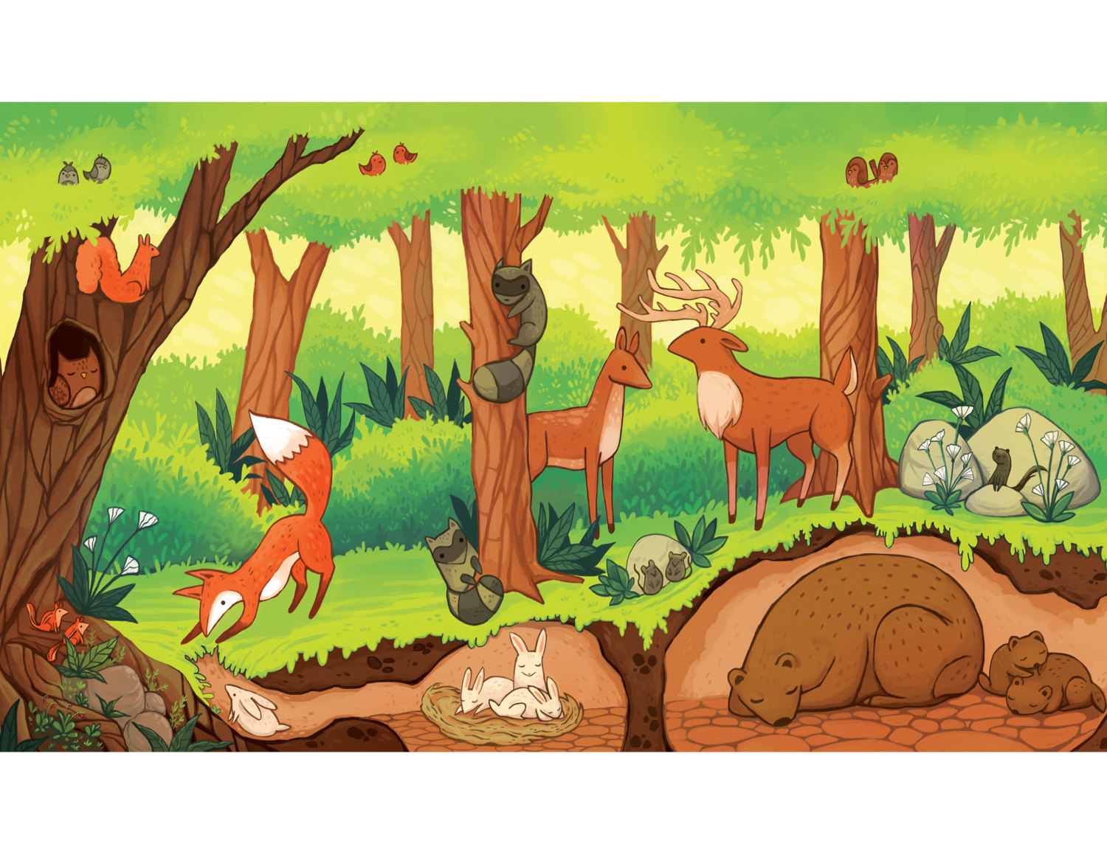

Biology 20

Field Study Guide – Unit B

Ecosystems and their Diversity

Biology 20 Field Study

This outline should be followed EXACTLY as it is laid out. Each group will be responsible for handing in one complete report. Reports should be done electronically to keep all of the information organized and concise.

Be creative – make your report colourful! You may wish to present your findings in a report book, scrap book or other media format.

Following the Experimental Plan on page 107 of your text book, you will conduct your field study. Please make sure to follow all safety guidelines and organize all of your assigned tasks and required materials ahead of time.

**Attitude Objectives**

1. You will demonstrate attitudes that support collaborative activity.
2. You will exhibit respect for the environment to ensure that it remains in its natural state.
3. You will practice proper safety procedures.

**Knowledge Objectives**

1. You will identify biotic and abiotic characteristics and explain their influence in an aquatic and a terrestrial ecosystem in the local region.
2. You will explain how terrestrial and aquatic ecosystems support a diversity of organisms through a variety of habitats and niches.
3. You will explain how limiting factors influence organism distribution and range.

**Skill Objectives**

1. You will formulate questions about observed relationships; plan investigations of questions, ideas, problems and issues; and define and delimit problems to facilitate investigation.
   * hypothesize the role of biotic and abiotic factors in ecosystems.
2. You will conduct investigations into relationships between and among observable variables and use a broad range of tools and techniques to gather and record data and information.
   * perform a field study to measure, quantitatively, appropriate abiotic characteristics of an ecosystem and to gather, both quantitatively and qualitatively, evidence for analysis of the diversity of life in the ecosystem studied.
3. You will use taxonomy and a dichotomous key to classify the biotic components of the ecosystem.
4. You will work collaboratively in addressing problems and apply the skills and conventions of science in communicating information and ideas and in assessing results.

Date: ____ / ____ / ____ Time _____: _____ am/pm Location: __________________________________

d m yr

**1. General Site Description**

Describe your site by placing a checkmark beside the correct category.

|  |  |  |  |  |
| --- | --- | --- | --- | --- |
| Weather Conditions | Wind Speed | Proximity to Water | Evidence of Disease | Evidence of Fire on Trees (burnt debris) |
| * Clear Sky * Partial Cloud * Overcast * Precipitation | * >40 km/h (trees sway) * 21-40 km/h (branches move) * 1-20 km/h (leaves rustle) * <1 km/h (smoke rises up…don’t try this test…fire risk) | * Near running water * Near pond or lake * Near slough, bog * No water | * Extensive   (>20 affected)   * Some (10-20 affected) * Limited   (<10 affected)   * None | * Numerous debris (>20 pieces) * Some debris (10-20 pieces) * Limited debris (<10 trees) * No evidence |

**2. Evidence of Wildlife Activity**

List the type of animal evidence found at the following levels (i.e. tracks, hair, scat/droppings, rubbings, chewed/grazed plants) and record the number observed. Be specific - e.g. Moose tracks, deer scat, actual squirrel

|  |  |  |  |
| --- | --- | --- | --- |
|  | Species | | Abundance |
| Plants |  | |  |
|  | |  |
|  | |  |
|  | |  |
| Land-Dwelling Animals and insects * | Signs: |  |  |
|  |  |
|  |  |
|  |  |
| Tree-Dwelling Animals and insects and microbes* | Signs: |  |  |
|  |  |
|  |  |
|  |  |
| Soil-Dwelling Animals, insects and microbes | Signs |  |  |
|  |  |
|  |  |
|  |  |

\**Look for droppings, feeding signs, habitat signs, nests, burrows, scratch marks, sounds smells, etc.*

Measure a 10m by 10m quadrat using a measuring tape, marking each corner so you can see the boundaries.

**3. Plot Study Diagram, and Vegetation Identification**

In the grid below, draw an aerial view of your plot. Include all plant, animal, human, and non-living evidence you observe. Complete the legend below including identifying specific plants. (e.g. white spruce Picea glauca)

|  |  |  |  |  |  |  |  |  |  |
| --- | --- | --- | --- | --- | --- | --- | --- | --- | --- |
|  |  |  |  |  |  |  |  |  |  |
|  |  |  |  |  |  |  |  |  |  |
|  |  |  |  |  |  |  |  |  |  |
|  |  |  |  |  |  |  |  |  |  |
|  |  |  |  |  |  |  |  |  |  |
|  |  |  |  |  |  |  |  |  |  |
|  |  |  |  |  |  |  |  |  |  |
|  |  |  |  |  |  |  |  |  |  |
|  |  |  |  |  |  |  |  |  |  |
|  |  |  |  |  |  |  |  |  |  |

North

Legend Type % Cover

e.g. M = Moss

_____=

_____=

_____=

_____=

_____=

_____=

_____=

**4. Measuring Trees**

Select a minimum of one average-sized tree in your plot and complete the following chart. * *See appendix for measurement instructions.*

|  |  |  |
| --- | --- | --- |
|  | Tree #1 | Tree #2 |
| Species |  |  |
| Diameter – (cm) |  |  |
| Height |  |  |

**5. Temperature (if you have a thermometer)**

For each temperature reading leave thermometer in place for at least 2 minutes.

**Thermometer Temperature**

1 m above ground- _____

At ground level- _____

10 cm below ground- _____

**6. Soil**

Using a soil sampler, or trowel, take a sample of the soil in your plot. Take **three** different layer samples of your plot. Record the pH of each soil layer using the litmus paper and technique learned in class. Take a small sample of soil and mix it with 2mL of distilled water. Then test this water with pH paper.

**Depth from Surface Soil Texture pH**

**Part B - Terrestrial Field Study Report**

1. Draw a chart in your notebook with the following columns: Abiotic & Biotic

a. Using your plot study sheets, assign each measurement collected to the associated column heading. (assign each of the 6 previous tasks to the appropriate column)

b. Which abiotic factor(s) have had the greatest effect on what you see in your field site? Why?

2. Draw a chart in your journal with the following columns:

|  |  |  |  |  |
| --- | --- | --- | --- | --- |
| Species Category | # of Organisms Counted | Divided by the total number of organisms sighted | Multiply by 100 | % Composition |
| Producer |  |  |  |  |
| Consumer |  |  |  |  |
| Decomposer |  |  |  |  |

Fill out your chart using the data from your field sheets

b. Using the percent composition calculated for each species category above, draw a pie chart representing the relative composition of each category.

c. Do you think that one species category is over- or under-represented because of the way the data was collected? Why or why not?

3. What effect would a change in the following have on your results:

a. Season

b. Precipitation

c. Disturbance such as forest fire or flooding

d. Human development

4. In analyzing your scientific method, list at least two concerns you have about the accuracy of your measurements. Be as specific or as general as you want to be.

Answer the following questions by considering your quadrat and the information you obtained. Use a separate sheet of paper.

1. Considering that your group sites were so close together, explain why **EACH** of their abiotic factors were not identical. If you think you obtained some unexpected/inaccurate data, explain what you expected and why.
2. Why were all the abiotic factors tested at the same time on the same day? Why was this important?
3. Consider the types of plants growing in each of your quadrats and the biotic and abiotic factors in each area. Why do different species of plants grow differently between the sites?
4. What evidence is there of human impact within your site? If human interference was eliminated in the Echo Glenn area, do you think your site would become more similar to the others over time? Explain.
5. Decomposers are an important part of an ecosystem. Describe their role in an ecosystem and explain their importance.
6. What limiting factors might affect the different species in your study site?
7. What evidence is there of intraspecific competition? If there is no evidence, do you suspect that there could be an intraspecific competition going on for resources in your ecosystem? Give a possible example.
8. Is there evidence of interspecific competition? If there is no evidence, do you suspect that there could be an interspecific competition going on between different species in your ecosystem? Give a possible example.

**Appendix**

**Measuring Tree Height**

Using a ruler, two students, and the following procedure:

Have one person ("Jane") stand at the base of the tree.

Measure Jane's height in metres.

A second person walks backwards, arm outstretched, both eyes open and holding the ruler, until the ruler exactly 'covers' the tree. Then, keeping the ruler steady, this person will measure and record the height Jane reaches on the ruler.

Find out the number of Janes the tree is by dividing the height of the tree, 30 cm in the ruler, by the height Jane comes to on the ruler. This determines the ratio of Jane to the tree.

Multiply this ratio by Jane’s measured height to determine the tree height.

For example:

If Jane reaches 2cm on the ruler, the number of Janes it would take to reach the top of the tree is 30cm ÷ 2cm = 15.

If Jane’s measured height is 1.2m, the height of the tree is 1.2m x 15 = 18m.

Once several different sized trees have been measured, use your own visual judgment on the relative sizes of other trees nearby.

**Measuring Tree Diameter**

Using a regular measuring tape, measure circumference approximately 1.3m off the ground by wrapping the tape measure around the tree. Diameter can then be determined using a calculator and the formula:

**d=C ÷ π (diameter = circumference / pi)**

**e.g. d = 72.22cm ÷ 3.14 = 23cm**

Using a ruler, diameter can be roughly estimated by holding the ruler up to the tree and measuring from widest point to widest point on the tree.