Lewis Formulas and Structural Formulas for Molecules

Practice Name: __________________
Fill in the following Tables:
(1 mark per blank)
Name | Electron Dot Diagram | Number of Lone Pairs | Number of Bonding Electrons
Sodium
Carbon
Nitrogen
Argon

Name | Formula | Electron Dot Diagram | Structural Formula
Ammonia
Liquid bromine
Hydrogen chloride
Nitrogen triiodide
 |  |  | 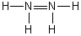
 | N₂
Carbon dioxide
Ethane
Ethene
Acetylene |  | 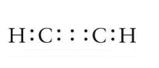
Water
 |  |  | 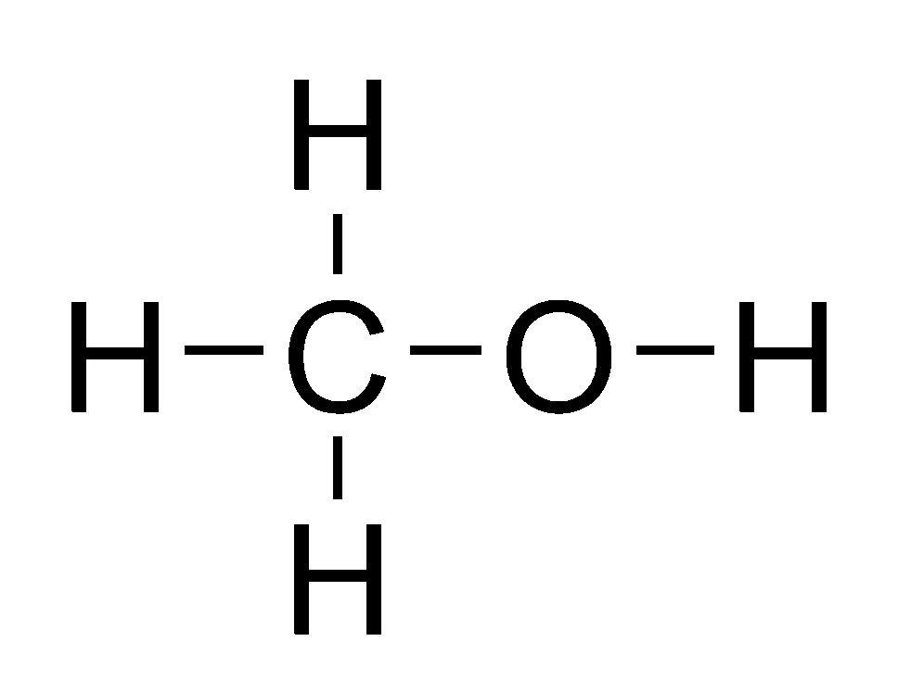
Chlorine
Oxygen disulfide
Hydrogen peroxide
Dichloroethane | C₂H₄Cl₂
Formaldehyde | H₂CO
 | HCN
Dichloroethyne | C₂Cl₂
Hydronium ion | H₃O⁺
 | NO³⁻
Nitrosyl | NO⁺
 | PO₄³⁻

